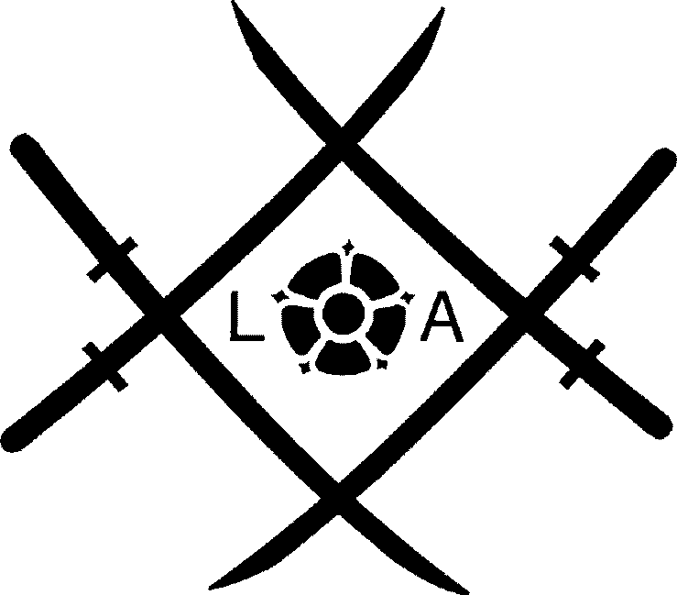
LANCASHIRE AIKIKAI
Application for Lancashire Aikikai & Club Membership and British Aikido Board Membership
This form MUST be completed in block capitals.

Surname: Forename(s): Address:

Telephone Number: Email Address:
(Please use capitals)

Age on date of joining:

I wish to become a member of the Lancashire Aikikai and the Club named on page 2, and agree to abide by their rules and constitution.
Date:
Signed (If under 18 – signed by parent, guardian or responsible adult on behalf)
Data Protection Statement

The personal data you provide will be held by your Club, with the information on Page 1 only being shared with Lancashire Aikikai. The basis on which the Aikikai and your Club processes your personal data is their legitimate interest in the following: administration purposes in managing a sports club, maintaining accurate membership records, safeguarding of members, informing members of news and information about the Aikikai and Aikido in general. Any health information on Page 2 is processed with your consent (see additional notice).

The British Aikido Board (BAB) is the Governing Body of Aikido. The Aikikai will provide the BAB with your name when first applying for, or renewing, your BAB membership, and other details in instances where it is necessary for the BAB’s functioning as a national governing body. The Aikikai and/or your Club will maintain its email distribution list using the Mailchimp system, which means your email address will be shared with Mailchimp. The Aikikai and/or your Club may publish personal details, including your name, and post photographs/videos on Social Media platforms for the purposes of promoting the Association and your Club.

You have the right to request a copy of your personal data and other rights such as erasure or correction of your personal data, as well as the right to make a complaint to the Information Commissioner’s Office. For further details see the Aikikai Data Protection Policy and Privacy Notice which is available on our website. The policy also summarises our approach to retention of personal data.

Lancashire Aikikai has a Data Protection officer who you can contact if you have any enquiries at the following email address: data@lancashireaikikai.org.
To be completed by the club
Trial / Visitor (BAB Slip)
New Member (Book)
Amount £
BAB Number
Expiry Date
Signed
Date

LANCASHIRE AIKIKAI
Club Name

Attach Photo Here

(optional for club)

Club Safeguarding Form
This form MUST be completed in block capitals.
Safeguarding Statement

Lancashire Aikikai and its member Clubs have obligations to the British Aikido Board (BAB), the governing body for Aikido, to take steps to protect the health, safety, wellbeing, and safeguarding of participants, and to mitigate any risks. As part of that activity, you are asked to provide the additional information on this page.
Surname:

Forename(s):
Who your Club should contact in an emergency

Emergency Contact Name:
Phone number:
Your relationship:
IMPORTANT INFORMATION - PLEASE READ
Please disclose any health problems or difficulties (physical or mental) that might affect you when training. For example, diabetes, asthma, heart or respiratory problems, dyspraxia, autism spectrum disorder, or any previous injuries that may affect your ability to practice a Martial Art:
Full disclosure is important for your own well-being and for insurance purposes. Further details concerning BAB insurance cover can be obtained on the BAB website.
Member Acknowledgement and Consent for Provision of Health Data

I acknowledge that Aikido is a Martial Art. I have disclosed above all relevant health problems and obtained medical advice to practice Aikido where necessary.
I understand that this health information is necessary for health and safety purposes, and for personal safeguarding, so that Club Instructors are able to look after my wellbeing and safety during training. I understand that any injuries or illnesses that affect my ability to practice must be brought to the attention of the Instructor before training, or during class if a new injury arises.
I consent to my Club processing the health data I have provided above and confirm I understand the specific purpose for which it will be used
(tick to confirm)
Date:
Signed (If under 18 – signed by parent, guardian or responsible adult on behalf)
Club Marketing Questionnaire

In order to monitor the effectiveness of our club marketing activities we would grateful if you could provide feedback on how you heard about the club? Please circle the relevant option below:
Information Leaflet
Internet (which site?) ………………..
Word of mouth
Other (please specify) …………………

