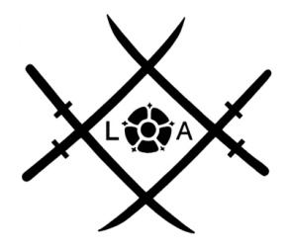 | Lancashire Aikikai  Safeguarding Form CP1  Additional information needed for young people below 18 years
Print in block capitals
Name of student :

To be completed by Parent, guardian or responsible adult
IF THE STUDENT IS UNDER 14 OR IF AN OLDER STUDENT WILL BE COLLECTED FROM CLASS
Names of all adults who may bring your child to aikido or collect from aikido including yourself

Name | Relationship | Address | Phone | *

If no one attends to collect your child at the end of the class – who should we contact? Tick in column marked *

I agree that my child can leave the aikido class unaccompanied. #

OR
I agree that my child will wait in the training room until picked up by one of the named people on this form. #

Delete one option leaving the option applicable that you want #

FOR ALL UNDER 18s
I confirm that if my child is injured during a class, I consent to the administration of first aid by a trained Aikido teacher, First Aider or helper. In an emergency or if you cannot be contacted within a reasonable time, I consent to my child being taken to hospital for treatment.
An information booklet explaining our expectations, child protection, and contact details will be emailed to you – using the email you have given. If you don’t receive this within the week – mention this to us.
[Insert Club Name] will, from time to time, take photographs and videos solely to promote Aikido and the Club. No personal information will be published of those under 18. This is within the policy for use of images set out by the governing body the British Aikido Board.
Others may not take images to prevent intrusive and inappropriate images being obtained. On that basis I consent to photographs and videos being taken in accordance with the policies.
The information you give above will be held by the club and will only be used by the Club & Aikikai and not given to external parties.

Signed ____________________________________________

Relationship to Child or Young Person __________________________
Date of signature __________________________

